1. Write a program that prints ‘Hello World’ to the screen.

print("Hello World")
OUTPUT:
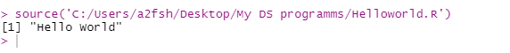
2. Write a program that asks the user for a number n and prints the sum of the numbers 1 to n

sum=0
for (i in 1:10)
{
sum=sum+i
}
print(sum)
OUTPUT:
3. Write a program that prints a multiplication table for numbers up to 12.

n=as.integer(readline("Enter number:"))
multiple<-function(num)
for (i in 1:12)
{
print(paste(num,"*",i,"=",num*i))
}
multiple(n)
OUTPUT:
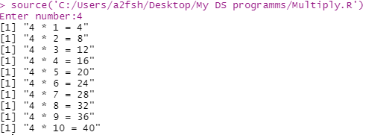
4. Write a function that returns the largest element in a list.

Maximum<-function(li)
{
m=0
for (i in li)
if(i > m)
m=i
print(m)
}

n=as.integer(readline("Enter number of terms:"))
x=list()
print("Enter elements of List")
for (i in 1:n)
x[i]=as.integer(readline(paste("Enter element",i,": ")))
Maximum(x)
OUTPUT:
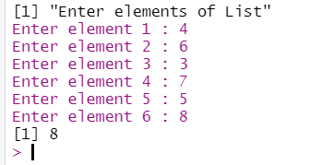

5. Write a function that computes the total of a list.
addition<-function(l)
{
sum=0
for (i in l)
sum=sum+i
print(sum)
}

n=as.integer(readline("Enter number of terms:"))
x=list()
print("Enter elements of list")
for (i in 1:n)
x[i]=as.integer(readline(paste("Enter element",i,": ")))
addition(x)
OUTPUT:
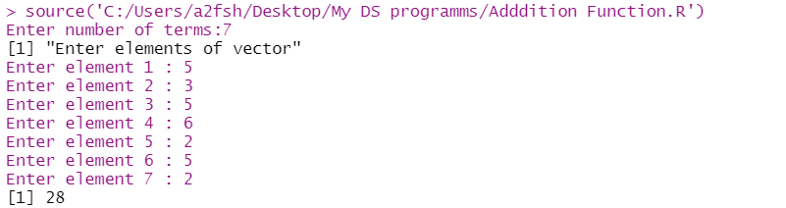
6. Write a function that tests whether a string is a palindrome.

Pallindrome<-function(str)
{
for (i in 1:nchar(str))
{
if(substr(str,i,i)!=substr(str,nchar(str)-i+1,nchar(str)-i+1))
{
print("String is not a palindrome")
return()
}
}
print("String is a pallindrome")
}

x=readline("Enter string to check pallindrome:")
Pallindrome(x)
OUTPUT:
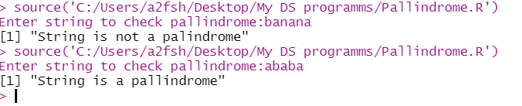
7. Implement linear search.

search<-function(vec)
{
flag=FALSE
num=as.integer(readline("Enter element to search : "))
j=1
for (i in vec)
{
if(i==num)
{
print(paste("Element found at",j))
flag=TRUE
#return()
}
j=j+1
}
if(flag==FALSE)
{
print("Element not found")
}
}
n=as.integer(readline("Enter number of terms:"))
x=c()
print("Enter elements of vector")
for (i in 1:n)
x[i]=as.integer(readline(paste("Enter element",i,": ")))
search(x)
OUTPUT:
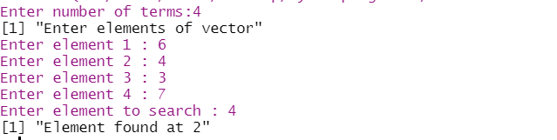
8. Implement binary search.

binsearch<-function(vec,s,e,num)
{
if(e>=s)
{
mid=(e+s)%/%2
if (vec[mid] == num)
{
return(mid)
}else if (vec[mid] > num)
{
return(binsearch(vec, s, (mid - 1), num))
}
else
{
return(binsearch(vec, (mid + 1), e, num))
}
}
else
return(-1)
}
n=as.integer(readline("Enter number of terms:"))
x=c()
print("Enter elements of vector")
for (i in 1:n)
x[i]=as.integer(readline(paste("Enter element",i,": ")))
num=as.integer(readline("Enter element to search : "))
sort(x)
if(binsearch(x,1,length(x),num)==-1)
{
print("Element not found")
}else
{
print(paste("Element found at",binsearch(x,1,length(x),num)))
}
OUTPUT:
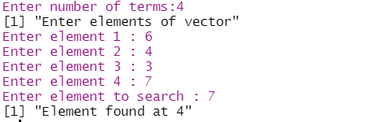

9. Implement matrices addition,
subtraction, Multiplication and other operations.

a=matrix(1:6,nrow=2,ncol=3,dimnames=list(c('r1','r2'),c('c1','c2','c3')))
#dimnames(a)=list(c('r1','r2'),c('c1','c2','c3'))
print(dimnames(a))
print(paste("No. of rows is:",nrow(a)))
print(paste("No. of cols is:",ncol(a)))
print("Matrix element (1,3)")
print(a[1,3])
print("Matrix full")
print(a)
print("Matrix row 1")
print(a[1,])
print("Matrix col 3")
print(a[,3])
a[1,3]=9
print(paste("Matrix updated element (1,3) is",a[1,3]))
a=rbind(a,r3=c(7,8,5))
a=cbind(a,c4=c(10,11,12))
print("Matrix full after adding row and column")
print(a)
b=matrix(1:12,nrow=3,ncol=4,byrow=TRUE,dimnames=list(c('r1','r2','r3'),c('c1','c2','c3','c4')))
print("Another matrix")
print(b)
a=a+b
print("Matrix full after adding another matrix to it")
print(a)
a=a-b
print("Matrix full after subtracting back another matrix from it")
print(a)
a=a*b
print("Matrix full after multiplying another matrix from it")
print(a)
a=a/b
print("Matrix full after dividing back another matrix from it")
print(a)
print(paste("Matrix test A",is.matrix(a)))
print(paste("Matrix test B",is.matrix(b)))
print(paste("Sum of row 1 of Matrix A",sum(a[1,])))
print(paste("Mean of col 1 of Matrix A",mean(a[,1])))
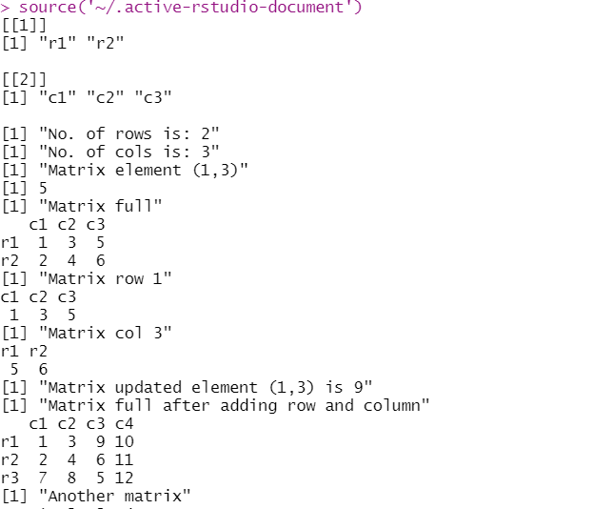
OUTPUT:
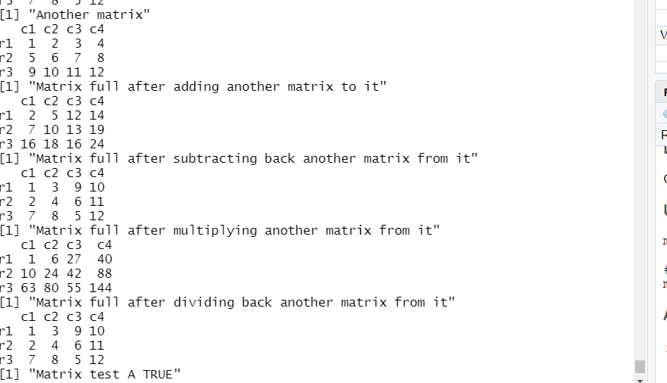

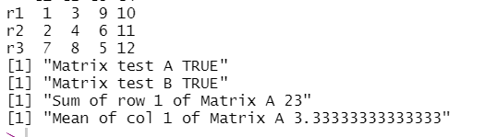
10. Fifteen students were enrolled in a course. There ages were:
20 20 20 20 20 21 21 21 22 22 22 22 23 23 23
i. Find the median age of all students.
ii. Find the median age of all students under 22 years.
iii. Find the mean age of all students.
iv. Find the modal age for all students v.
v. Two more students enter the class. The age of both students is 23. What is now mean,
mode and median?

mode<-function(vec)
{
t=table(vec)
n=names(which(t==max(t)))
return(n)
}

Age=c(20,20,20,20,20,21,21,21,22,22,22,22,23,23,23)
print(Age)
print("Find the median age of all students under 22 yrs")
print(median(Age[Age<22]))
print("Find the median age of all students")
print(median(Age))
print("Find the mean age of all students")
print(mean(Age))
print("find the modal age of all studnets")
print(mode(Age))

print("Two more students enter the class. The age of both studnets is 23")
Age1=c(Age,23,23)
print(Age1)
print("Find the median age of all students under 22 yrs")
print(median(Age1[Age1<22]))
print("Find the median age of all students")
print(median(Age1))
print("Find the mean age of all students")
print(mean(Age1))
print("find the modal age of all studnets")
print(mode(Age1))
OUTPUT:
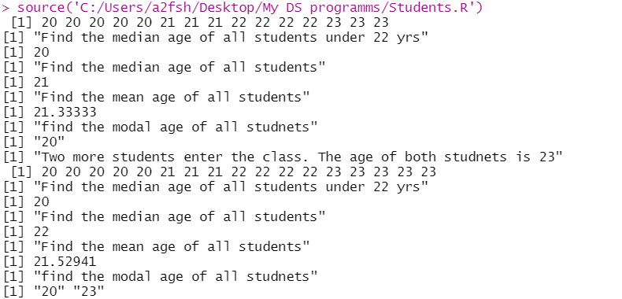
11. Following table gives a frequency distribution of systolic blood pressure. Compute all the
measures of dispersion:
Midpoint n
95.5 5
105.5 8
115.5 22
125.5 27
135.5 17
145.5 9
155.5 5
165.5 5
175.5 2

dispersion<-function()
{
bp=c(rep(95.5,5),rep(105.5,8),rep(115.5,22),rep(125.5,27),rep(135.5,17),rep(145.5,9),rep(155.5,5),rep(165.5,5),rep(175.5,2))
print(mean(bp))
print(range(bp))
print(var(bp))
print(sd(bp))
print(unique(bp))
print(unique(mean(bp)-bp))
print(quantile(bp))
print(summary(bp))
out=boxplot(bp)$out
print(out)
a=which(bp%in%out)
print(a)
print(mode(bp))
}
dispersion()
mode<-function(vec)
{
t=table(vec)
n=names(which(t==max(t)))
return(n)
}
OUTPUT:
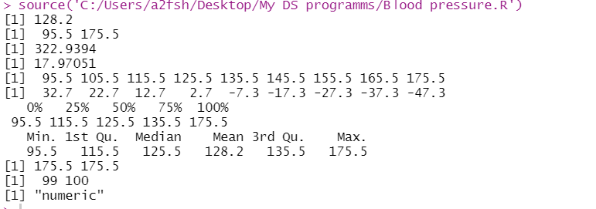
12. Randomly generate 30 numbers in the range of 1 to 40 and do the following
i) Generate box plot
ii) Identify outliers, if any
iii) Display 5 point summary of data distribution

#U=c(floor(rnorm(30)%%40+1))
#U=sample(1:40,size = 30)
U=c(1,2,2,3,2,1,3,2,4,2,5,4,100,-100)
print(U)
boxplot(U)
outlier <- boxplot.stats(U)
print(outlier)
print(summary(U))
print(fivenum(U))
V=runif(40,min=1,max=30)
print(V)
floor(V)
OUTPUT:
